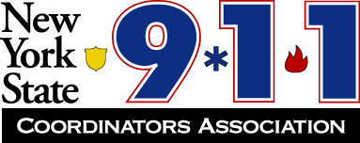

Officers:

President  Marc E Kasprzak  Niagara County | Vice President  Kevin Pooley  Oswego County | Secretary  Lisa Sears  Erie County | Treasurer  Katie Dean  Wayne County

Fall 2024 Conference – Chautauqua County
October 1 – October 3, 2024
Chautauqua Harbor Hotel
10 Dunham St.
Celoron, NY 14720
716-489-2800

Retired Members Registration Form (one form per person)

Attendee: _____________________________________________________
Agency: ______________________________________________________
Address: ______________________________________________________
E-mail and phone#: _____________________________________________

The Fall Conference will begin at 0730 hours Tuesday with breakfast and registration. Breakfast, lunches, and special events are included in registration. Dinners are not included. Refer to the agenda for Wednesday and Thursday start times and events. Hotel Rate: $107.00 per night for standard room, $127.00 per night for Lake View or Lake View Patio Reference NYS 911 Coordinators Association when reserving room(s).

Our retirees are welcome to attend our conference free but must cover their room expenses and register prior to conference with Amanda Schultz. For guests of our retirees, the cost is $50.00.

Full 3-day Conference Registration for a Guest of a Retiree: $50.00

Registration fee paid: $_____________

Send registrations and payments to Katie Dean

Checks payable to: NYS 911 Coordinators Association

We also accept credit cards!

Send checks to: Katie Dean, Treasurer
7376 Route 31, Suite 911
Lyons, NY 14489
315.946.5782
KDean@co.wayne.ny.us

