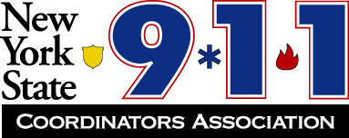

Officers:

President  Marc E Kasprzak  Niagara County | Vice President  Kevin Pooley  Oswego County | Secretary  Lisa Sears  Erie County | Treasurer  Katie Dean  Wayne County

Fall 2024 Conference – Chautauqua County
October 1 – October 3, 2024
Chautauqua Harbor Hotel
10 Dunham St.
Celoron, NY 14720
716-489-2800

Members Registration Form (one form per person)

Attendee: _____________________________________________________
Agency: ______________________________________________________
Address: ______________________________________________________
E-mail and phone#: _____________________________________________

The Fall Conference will begin at 0730 hours Tuesday with breakfast and registration. Breakfast, lunches, and special events are included in registration. Dinners are not included. Refer to the agenda for Wednesday and Thursday start times and events. Hotel Rate: $107.00 per night for standard room, Lake View and Lake View Patio: $127.00 per night Must reference NYS 911 Coordinators when reserving room(s).

Full 3-day Conference Registration: $150.00
Single Day Registration: $90.00 ________________ specify the day for meal count

Registration fee paid: $_____________

Send registrations and payments to Katie Dean

Checks payable to: NYS 911 Coordinators Association

We also accept credit cards!!!

Send checks to: Katie Dean, Treasurer
7376 Route 31, Suite 911
Lyons, NY 14489
315.946.5782
KDean@co.wayne.ny.us

